AI APPLICATIONS
AI for Smarter Business
AI for Engineering Solutions
Study notes for UG Second Year students

What you will learn in these notes
• How AI helps businesses work faster, cheaper and smarter
• How AI is used in different branches of engineering
• The main AI techniques behind these applications
• Two worked Python examples: predictive maintenance and demand forecasting
• Smart factories, visual inspection and Industry 4.0
• How to judge the business value (ROI) of an AI project
• Steps for adopting AI, and the challenges and risks involved

1. Introduction: Why AI in Business and Engineering?
Every business, from a small workshop to a large factory, must keep making decisions: how much to produce, when to repair a machine, which customer to contact, what price to charge. Traditionally these decisions were based on experience and fixed schedules. Today, machines, phones and websites record huge amounts of data, and Artificial Intelligence (AI) can learn patterns from this data to support better decisions. Businesses that use AI well are often called smarter businesses.
Engineering is at the centre of this change. Engineers design the sensors that collect data, build the systems that process it, and use AI to solve technical problems such as predicting machine failures, saving energy or inspecting products. This is called AI for engineering solutions.

1.1 Why is AI possible and useful now?
- More data: sensors, mobile phones, websites and machines record data every second.
- Cheaper computing: powerful computers and cloud services are available to many organisations.
- Better algorithms: machine learning methods (see the notes on Learning from Data) have become more accurate and easier to use.

1.2 What do businesses want from AI?
Goal | How AI helps
Lower cost | Predict failures early, reduce waste, optimise energy and stock.
Higher quality | Inspect every product automatically with cameras and models.
Faster work | Automate routine tasks such as answering common customer questions.
Better decisions | Forecast demand and risks using data instead of guesswork.
Better customer experience | Personalised recommendations and quick support.
Safety | Detect dangerous conditions and unsafe behaviour early.

1.3 Traditional versus AI-enabled business
Aspect | Traditional | AI-enabled (smart)
Decisions | Based on experience and rules of thumb | Based on data and learned patterns
Maintenance | After breakdown or on a fixed calendar | When the data shows it is needed
Customers | Same offer for everyone | Personalised for each customer
Quality checks | Manual sampling by people | Automatic checking of every item
Planning | Fixed yearly plan | Forecasts updated continuously

2. AI for Smarter Business
AI can be used at almost every stage of a business, from buying raw materials to serving customers after the sale. The figure shows where it commonly helps.
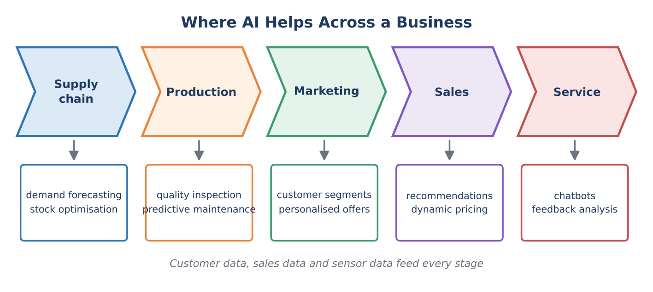
Figure 1: Typical AI uses across the stages of a business
Application | What it does | Example
Demand forecasting | Predicts how much customers will buy in the coming days or months. | A retailer decides how many units to stock for a festival month.
Recommendation systems | Suggests products that a customer is likely to like. | “Customers who bought this also bought…” on a shopping site.
Chatbots and virtual assistants | Understand questions in natural language and reply instantly. | A bank chatbot that answers balance and card queries.
Fraud detection | Spots unusual transactions that do not match normal behaviour. | A payment is blocked because it is far from the customer’s usual pattern.
Dynamic pricing | Adjusts prices according to demand, time and competition. | Ticket and travel prices that change with demand.
Customer segmentation | Groups customers with similar behaviour (clustering). | Separate offers for students, families and frequent buyers.
Sentiment analysis | Reads reviews and comments to find whether opinions are positive or negative. | A company tracks reactions to a new product.
Inventory and logistics | Plans stock levels and delivery routes. | Choosing the shortest delivery route for many orders.

Remember
Behind most of these applications are the same ideas you have already learned: classification (is this transaction fraud?), regression (how many units will sell?), and clustering (which customers are similar?).

3. AI for Engineering Solutions
Engineering problems often involve machines, structures, circuits and processes that produce data. AI can learn from this data to predict, detect, control and design. Every branch of engineering has its own uses.
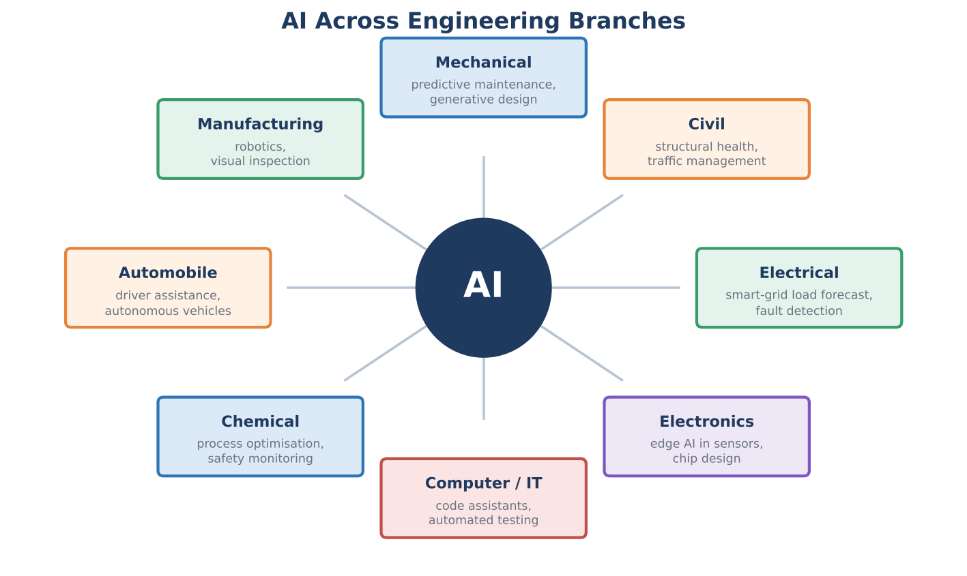
Figure 2: Examples of AI applications in different engineering branches
Branch | Engineering problem | AI solution
Mechanical | Machines break down unexpectedly; designs must be strong but light. | Predictive maintenance from vibration data; generative design of lighter parts.
Civil | Bridges and buildings age; city traffic is congested. | Sensors and models to detect structural damage early; smart signals that adapt to traffic.
Electrical | Electricity demand changes through the day; faults must be found quickly. | Load forecasting for the smart grid; automatic fault detection and classification.
Electronics and embedded | Devices need to be smart but use very little power. | Edge AI: small models running on sensors and microcontrollers.
Computer / IT | Software is large and bugs are costly. | AI assistants for coding, testing and finding vulnerabilities.
Chemical and process | Plants must run safely at the best temperature and pressure. | Models that optimise the process and give early warnings of unsafe conditions.
Automobile | Safer and more efficient driving. | Driver-assistance systems, lane and obstacle detection, route planning.
Manufacturing | Defects, slow lines and costly downtime. | Robots, visual inspection and production scheduling.

4. AI Techniques Behind These Applications
Different problems need different AI techniques. The table links each technique to its use in engineering and business.
Technique | What it does | Engineering / business use
Machine learning (prediction) | Learns patterns from past data to predict numbers or categories. | Forecasting demand, predicting remaining life of a machine, classifying faults.
Computer vision | Understands images and video. | Detecting cracks and scratches, reading number plates, checking safety helmets.
Natural language processing (NLP) | Understands and produces human language. | Chatbots, reading customer reviews, summarising reports.
Anomaly detection | Finds data that does not fit the normal pattern. | Spotting unusual sensor readings or suspicious payments.
Optimisation and search | Finds the best choice among very many options (for example genetic algorithms). | Delivery routes, timetables, production schedules, design parameters.
Reinforcement learning | Learns the best actions by trial, error and reward. | Robot control, energy management in buildings.
Expert systems (rule-based AI) | Uses rules written by human experts. | Troubleshooting guides, safety interlocks.
Digital twin and simulation | A virtual model of a real machine or plant that is fed with live data. | Testing changes safely before applying them to the real machine.
Generative AI | Creates new text, code, images or design options from a description. | Drafting reports and code, suggesting design alternatives.

4.1 Generative design in a nutshell
In generative design, the engineer does not draw one fixed shape. Instead the engineer tells the software the goals and limits (for example: carry this load, weigh as little as possible, use this material, cost below a given value). The software generates many possible shapes, often with organic, bone-like forms, and the engineer chooses and verifies the best one. AI offers options; the engineer still takes the final design decision.

5. Case Study 1: Predictive Maintenance

5.1 The problem
A factory runs hundreds of motors, pumps and fans. When a machine breaks suddenly, production stops and repairs are expensive. Maintenance can be organised in three ways.
Type | Idea | Advantage | Disadvantage
Reactive | Repair only after the machine fails. | No planning needed. | Unplanned stoppages, high cost, safety risk.
Preventive | Service on a fixed schedule (for example every 3 months). | Fewer surprises. | Parts may be replaced too early or failure may still occur between services.
Predictive (AI) | Service when sensor data shows the machine is getting worse. | Repair at the right time; less downtime. | Needs sensors, data and skilled people.

5.2 How it works
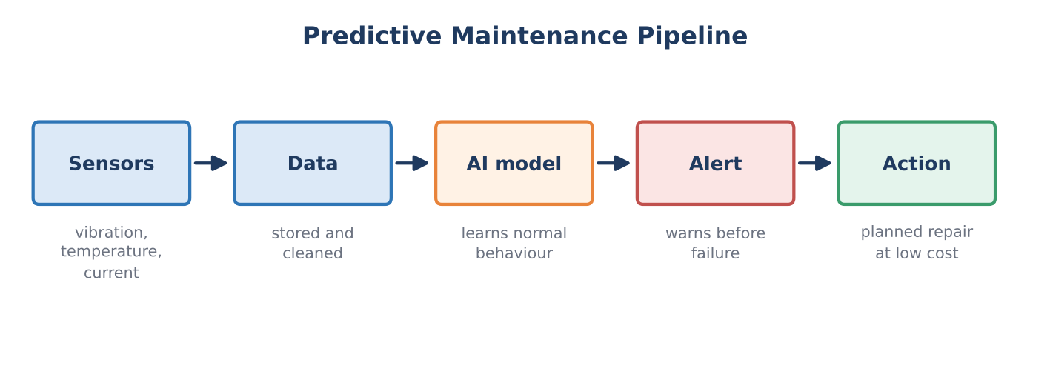
Figure 3: The predictive maintenance pipeline
Sensors measure signals such as vibration, temperature and electric current. A healthy machine has a stable pattern. As a part such as a bearing wears out, the vibration slowly rises. An AI model (or even a simple rule) watches for this change and raises an alert before the machine breaks.

5.3 A small program
The program below uses simulated vibration data for 100 days. The machine is healthy at first; bearing wear starts at day 70. The program smooths the noise with a 5-day moving average and raises an alert when the smoothed value crosses a limit. The numbers are illustrative; real limits come from machine manuals and past data.
Python code
import numpy as np
import pandas as pd

# 1. Simulated daily vibration readings of a motor (mm/s)
rng = np.random.default_rng(7)
days = np.arange(1, 101)
vibration = 2.0 + rng.normal(0, 0.25, 100) # healthy machine
vibration[69:] += np.linspace(0, 3.2, 31) # wear starts on day 70
df = pd.DataFrame({"day": days, "vibration": vibration.round(2)})

# 2. Smooth the noise with a 5-day moving average
df["trend"] = df["vibration"].rolling(5).mean().round(2)

# 3. Alert rule: warn when the trend crosses the limit
LIMIT = 4.0
alerts = df[df["trend"] > LIMIT]
first_alert = int(alerts["day"].iloc[0])

healthy = df.loc[:59, "vibration"].mean()
on_alert_day = df.loc[df["day"] == first_alert, "trend"].iloc[0]
print("Healthy average (days 1-60):", round(healthy, 2), "mm/s")
print("Alert limit:", LIMIT, "mm/s")
print("First alert on day:", first_alert)
print("Trend on that day:", on_alert_day, "mm/s")

Output when the program is run
Healthy average (days 1-60): 1.95 mm/s
Alert limit: 4.0 mm/s
First alert on day: 91
Trend on that day: 4.09 mm/s

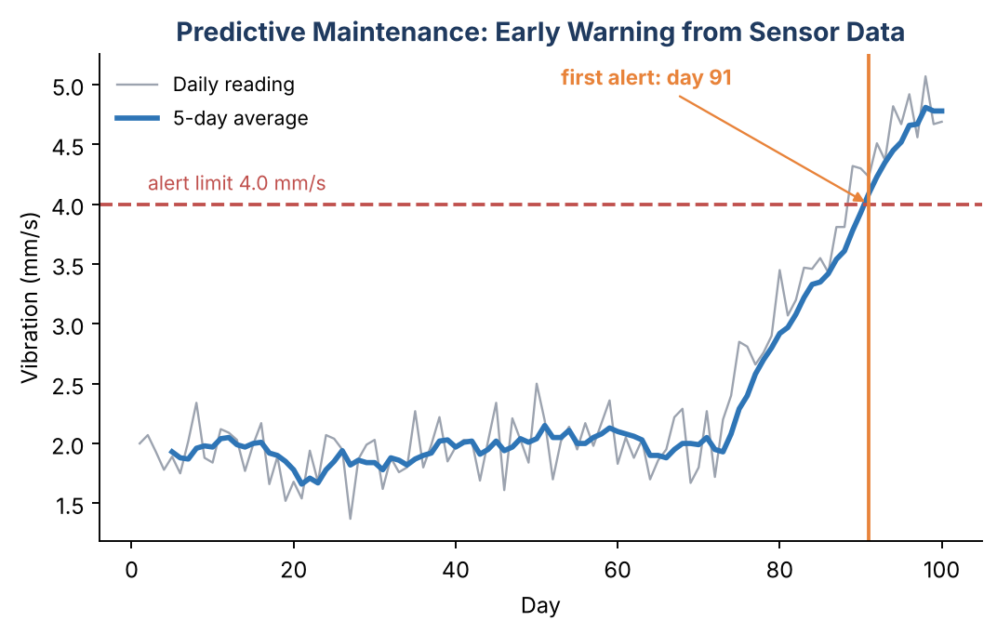
Figure 4: Vibration rises after day 70; the alert is raised on day 91
The alert comes about three weeks after the wear began, while the machine is still running. The maintenance team can now plan the repair for a convenient time instead of facing a sudden breakdown.
In real projects
Real systems usually go further: they train a machine-learning model on past sensor data and past failures to estimate the Remaining Useful Life (RUL) of the machine. The simple limit-based rule in this example is the first step and is often used as a baseline.

6. Case Study 2: Demand Forecasting
A business must decide how much to produce or stock. Too little stock loses sales; too much stock wastes money and space. Demand forecasting uses past sales to estimate future demand. Here we use the simplest model: a straight line (linear regression, as learned in the notes on Learning from Data).
Python code
import numpy as np

# 1. Monthly sales (units) of a product for the last 12 months
months = np.arange(1, 13)
sales = np.array([120, 128, 126, 138, 145, 142,
155, 160, 158, 170, 176, 181])

# 2. Learn a straight-line trend: sales = m * month + c
m, c = np.polyfit(months, sales, 1)

# 3. Forecast the next 3 months
future = np.arange(13, 16)
forecast = m * future + c

print("Trend: sales grow by about", round(m, 1), "units per month")
for mo, f in zip(future, forecast):
print("Month", mo, "forecast:", round(f), "units")

Output when the program is run
Trend: sales grow by about 5.5 units per month
Month 13 forecast: 186 units
Month 14 forecast: 191 units
Month 15 forecast: 197 units

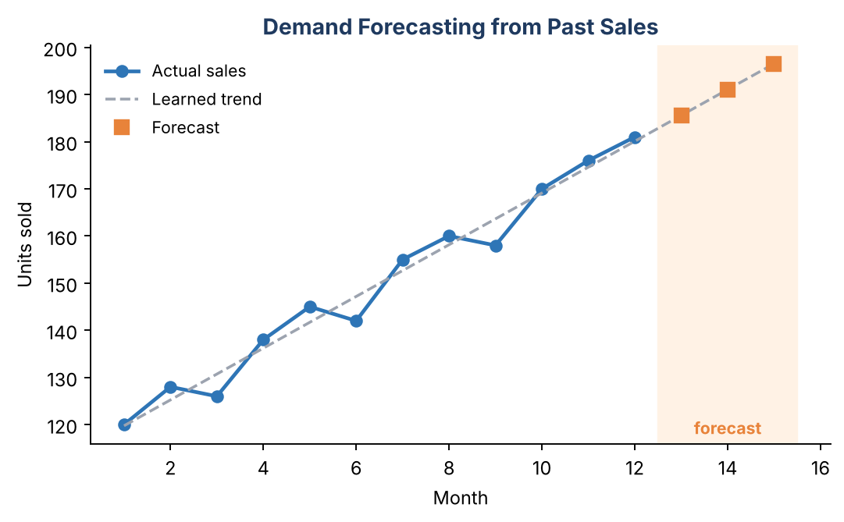
Figure 5: A learned trend line is extended to forecast the next three months
- np.polyfit(months, sales, 1): finds the best straight line, giving slope m and intercept c.
- Slope (about 5.5): on average the product sells 5.5 more units each month.
- Forecast: put future month numbers into the line to estimate the sales.
Limits of this simple model
A straight line ignores seasons, festivals, price changes and promotions. Real forecasting models include such factors, and the forecast should always be reviewed by people who know the market. A forecast is an estimate, not a promise.

7. Smart Manufacturing and Industry 4.0
Industry 4.0 is the idea of connecting machines, sensors, software and people so that a factory can monitor itself and improve continuously. The key ingredients are the Internet of Things (IoT), cloud computing, AI and robotics.
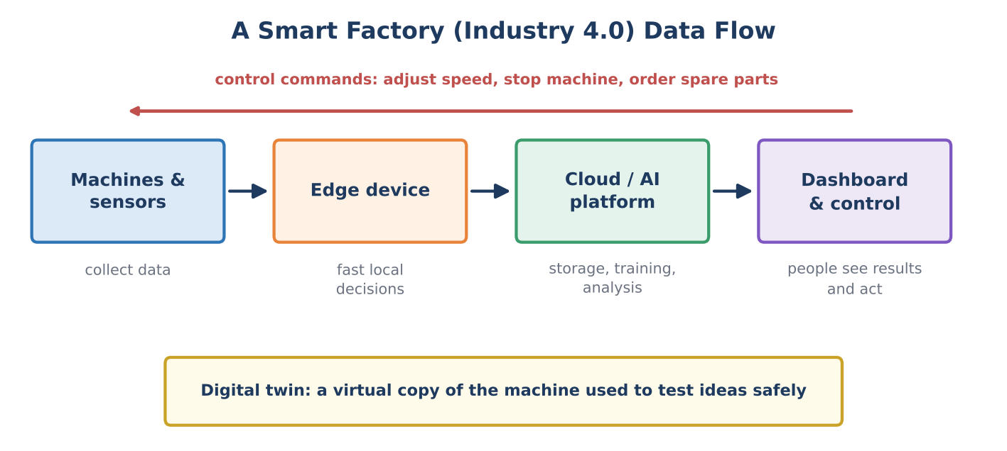
Figure 6: Data flow in a smart factory
- Machines and sensors collect data (speed, temperature, vibration, output count).
- Edge devices process data close to the machine so that urgent decisions are fast, even without internet.
- Cloud / AI platform stores large amounts of data, trains models and finds patterns across many machines.
- Dashboards show results to people, and control commands can flow back to adjust or stop machines.
- A digital twin lets engineers test a change on a virtual copy before touching the real machine.

7.1 Visual quality inspection
In many factories, people check products by eye, which is slow and tiring. With computer vision, a camera photographs every product on the conveyor belt and an AI model, trained on thousands of images of good and faulty parts, decides whether to pass or reject it.
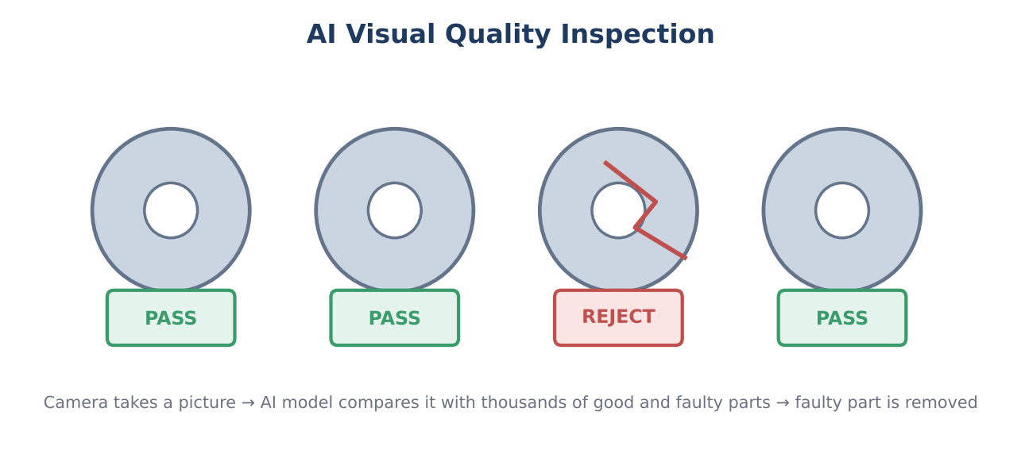
Figure 7: AI inspection – each part is checked and faulty parts are rejected

7.2 Other smart-factory uses
- Robots and cobots: robots that handle repeated tasks; “cobots” work safely beside people.
- Energy optimisation: models that reduce power use by controlling machines and air-conditioning intelligently.
- Safety monitoring: cameras that detect missing safety helmets or people entering danger zones.
- Production scheduling: optimisation methods that decide which job runs on which machine and when.

8. Business Value: Is the AI Project Worth It?
A company will adopt AI only if it brings more benefit than it costs. This is measured with Return on Investment (ROI).
Formula
Net benefit = Benefit (savings or extra income) − Cost of the AI system
ROI (%) = (Net benefit ÷ Cost of the AI system) × 100

Worked example (illustrative numbers)
A machine is stopped by breakdowns for 40 hours per year. Each hour of stoppage costs ₹25,000.
Downtime cost = 40 × 25,000 = ₹10,00,000 (10 lakh).
Predictive maintenance reduces downtime by 50%, so the saving = ₹5,00,000.
The AI system (sensors, software, support) costs ₹2,00,000 per year.
Net benefit = 5,00,000 − 2,00,000 = ₹3,00,000.
ROI = (3,00,000 ÷ 2,00,000) × 100 = 150%.

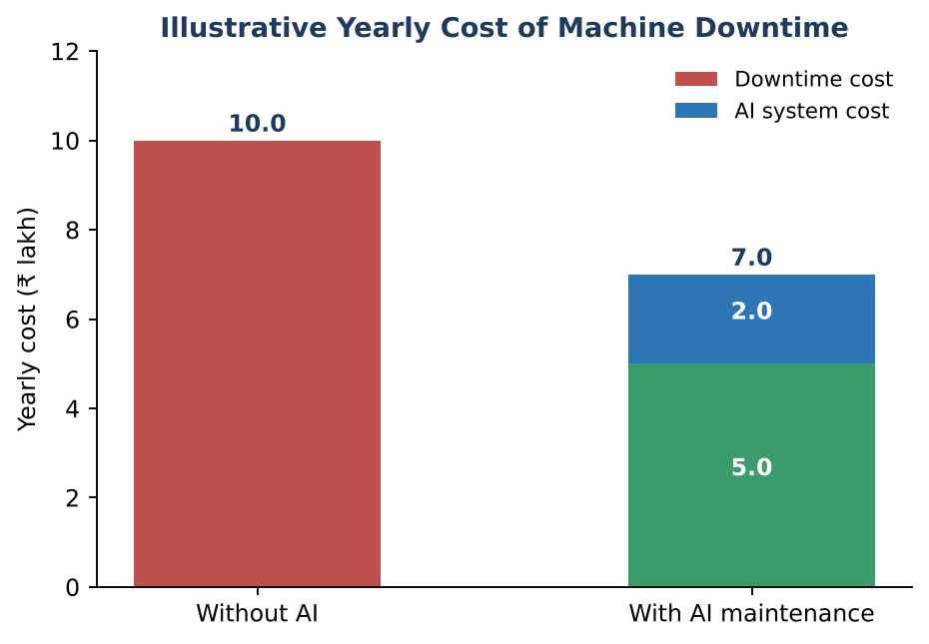
Figure 8: Yearly cost with and without AI maintenance (illustrative)
Besides money, businesses also value benefits that are harder to measure: safer workplaces, happier customers, better product quality and a stronger reputation.

9. How to Adopt AI in a Business
Successful AI projects start small and grow step by step. A common roadmap is shown below.
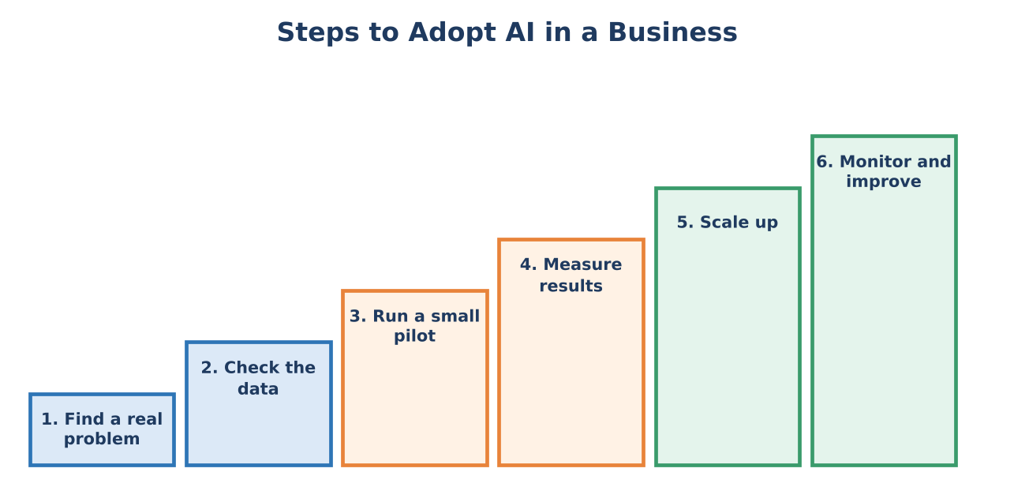
Figure 9: A step-by-step roadmap for adopting AI
- Find a real problem. Start with a clear business or engineering pain point (for example, too much downtime), not with the technology.
- Check the data. Is there enough data, is it accurate, and who owns it? Without data, AI cannot learn.
- Run a small pilot. Try the idea on one machine or one product line first.
- Measure results. Compare with the old method using numbers such as downtime hours or defect rate.
- Scale up. Extend to more machines or locations when the pilot works and trained people are available.
- Monitor and improve. Models can become outdated when conditions change, so keep checking and retraining.

9.1 Who works on an AI project?
Role | Contribution
Domain engineer | Understands the machine or process; defines the problem and checks that results make sense.
Data engineer | Collects, stores and cleans the data; builds data pipelines.
Data scientist / AI engineer | Builds, trains and tests the models.
IT / security team | Connects systems and protects data and devices.
Manager | Sets goals, budget and rules; manages people and change.

10. Challenges, Risks and Responsible Use
Challenge | Explanation
Data quality and quantity | Missing, noisy or biased data gives poor models. Rare events such as failures have few examples.
Cost and skills | Sensors, software and trained people need investment, especially for small businesses.
Old (legacy) machines | Old equipment may have no sensors or digital connection and is hard to integrate.
Safety and reliability | In bridges, aircraft, medical devices and power plants, a wrong AI decision can cause serious harm.
Explainability | Some models act as a “black box”; engineers and regulators need to know why a decision was made.
Cybersecurity | Connected machines and data can be attacked or misused.
Privacy | Customer and worker data must be collected and used lawfully and fairly.
Bias and fairness | Models can treat groups unfairly, for example in hiring or lending decisions.
Jobs and skills | Some tasks will be automated and new tasks created, so workers need training.
Accountability | A person or company, not the AI, remains responsible for decisions and their results.

Engineering judgement comes first
In safety-critical engineering, AI should support and not replace engineering knowledge, testing and standards. AI results should be validated, and a qualified person should approve important decisions (human in the loop).

11. Future Trends
- AI assistants for engineers: tools that help write code, draft reports, explain standards and suggest design options, with the engineer checking the output.
- Edge AI: more intelligence inside small devices, giving faster response and lower data transfer.
- Digital twins: more detailed virtual copies of machines, buildings and even whole cities.
- Autonomous systems: self-driving vehicles, drones and robots working with greater independence.
- AI for sustainability: better energy use, less waste and smarter use of resources.
- Human–AI teamwork: the most valuable engineers will combine strong fundamentals with the ability to use AI tools wisely.
These trends are developing quickly, so engineers must keep learning throughout their careers.

12. Summary – Key Points to Remember
Quick revision
• A smarter business uses data and AI to cut cost, improve quality, speed up work and serve customers better.
• Business uses: forecasting, recommendations, chatbots, fraud detection, dynamic pricing, segmentation.
• Engineering uses: predictive maintenance, visual inspection, smart grids, generative design, robotics, process optimisation.
• Key techniques: machine learning, computer vision, NLP, anomaly detection, optimisation, reinforcement learning, digital twins, generative AI.
• Predictive maintenance repairs machines when data shows the need: better than reactive or fixed-schedule maintenance.
• Industry 4.0 connects machines, sensors, edge, cloud and people; a digital twin is a virtual copy used for safe testing.
• ROI (%) = (Net benefit ÷ Cost) × 100.
• Adopt AI step by step: problem → data → pilot → measure → scale → monitor.
• Watch out for poor data, cost, safety, explainability, security, privacy, bias and accountability.

13. Practice Questions

A. Short answer (2 marks)
- What is a smarter business? Give two examples of AI use in business.
- Define predictive maintenance. How is it different from preventive maintenance?
- What is a digital twin?
- What is anomaly detection? Give one engineering example.
- Write the formula for ROI.
- What is computer vision? Where is it used in a factory?

B. Descriptive (5 / 10 marks)
- Explain, with a diagram, where AI can be applied across the stages of a business.
- Describe AI applications in any four branches of engineering.
- Explain the predictive maintenance pipeline with a suitable example.
- Explain how a smart factory works (Industry 4.0), mentioning sensors, edge, cloud and digital twin.
- Explain the roadmap for adopting AI in a company.
- Discuss the challenges and risks of using AI in engineering and how they can be reduced.

C. Numerical
- A machine stops for 30 hours per year and each hour costs ₹20,000. AI maintenance cuts downtime by 40% and the system costs ₹1,50,000 per year. Find the saving, the net benefit and the ROI.
- A shop sold 100, 110 and 120 units in three consecutive months. Using a straight-line trend, forecast the sales for the next month.

D. Mini projects / discussion
- Choose a machine or process from your own branch of engineering. List the sensors you would use, the data you would collect, and the decision the AI should support.
- Change the limit in the predictive maintenance program from 4.0 to 3.0 mm/s. Predict the new alert day, then run the program to check. Discuss the risk of setting a limit too low or too high.
- Collect 12 months of data (for example your monthly mobile data use or electricity units) and use the forecasting program to estimate the next month. How accurate was it?

Answers to the numerical questions
Q1. Downtime cost = 30 × 20,000 = ₹6,00,000. Saving at 40% = ₹2,40,000. Net benefit = 2,40,000 − 1,50,000 = ₹90,000. ROI = (90,000 ÷ 1,50,000) × 100 = 60%.
Q2. The sales rise by 10 units each month, so the next month’s forecast = 130 units.

14. Glossary
Term | Meaning
Anomaly | A data point that does not fit the normal pattern.
Cobot | A collaborative robot designed to work safely beside people.
Computer vision | AI that understands images and video.
Demand forecasting | Estimating future customer demand from past data.
Digital twin | A virtual copy of a machine or system, kept updated with real data.
Edge AI | Running AI models on or near the device instead of in a distant cloud.
Generative design | Software that produces many design options from goals and constraints.
Industry 4.0 | Connected, data-driven, smart manufacturing.
IoT | Internet of Things: everyday devices and machines connected to the internet.
Predictive maintenance | Repairing equipment when data indicates it is about to fail.
ROI | Return on Investment: net benefit compared with cost, as a percentage.
RUL | Remaining Useful Life: how long a machine can run before it needs repair.
Sensor | A device that measures a physical quantity such as temperature or vibration.

— End of Notes —

